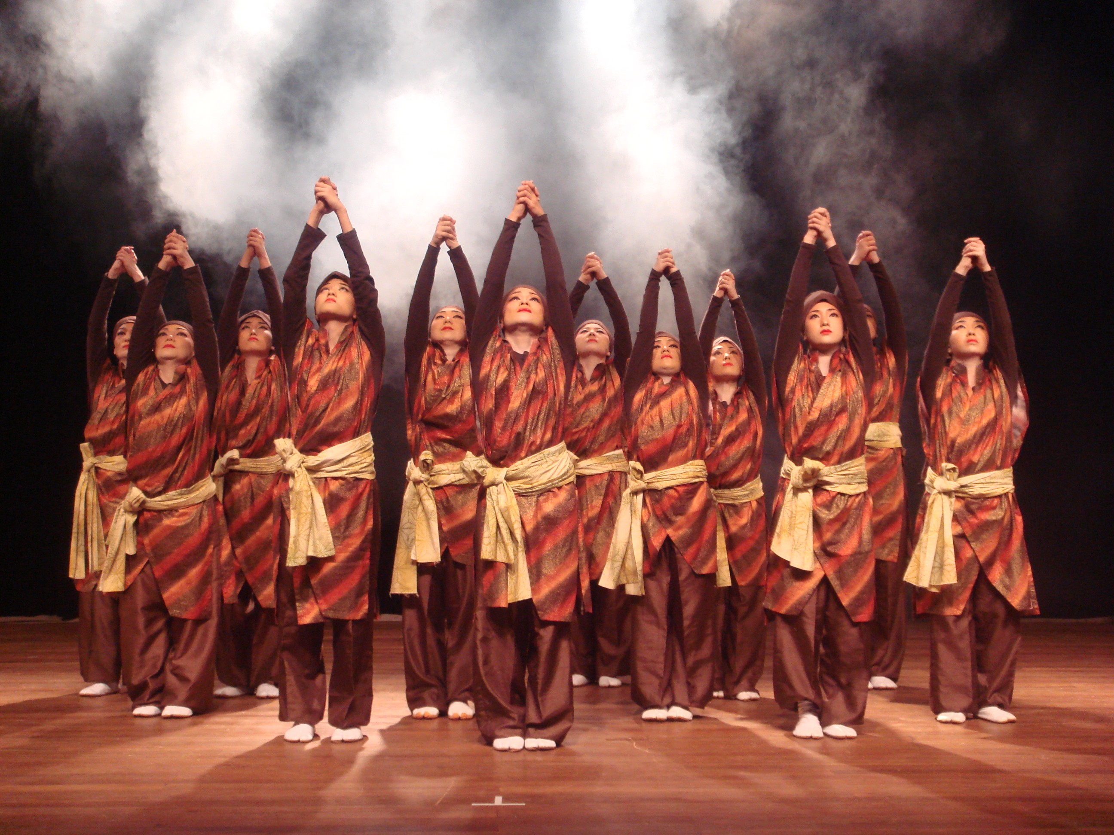

Date： Wednesday 11, 2011 8:00-9:30pm

Place： Y auditorium, Zayed University Abu Dhabi Campus

Program： History of Okinawa Island arranged by Chura

Admission： Free

Chura is a company of professional women performers who have performed more than thousand times in over 30 countries. Chura brings classical Okinawa dance to contemporary audiences in celebration of the traditions of Japan.

There is a donation box in the venue for the Japanese earthquake victims.



Funded by:
The Japanese Agency for Cultural Affairs
Sponsored by:
The Embassy of Japan in the UAE,
The International College, Zayed University

Date： Saturday 14, 2011 8:00-9:30pm

Place： Main Auditorium, Zayed University Dubai Campus

Program： History of Okinawa Island arranged by Chura

Admission： Free

Chura is a company of professional women performers who have performed more than thousand times in over 30 countries. Chura brings classical Okinawa dance to contemporary audiences in celebration of the traditions of Japan.

There is a donation box in the venue for the Japanese earthquake victims.

Funded by:
The Japanese Agency for Cultural Affairs
Sponsored by:
The embassy of Japan in the UAE
The International College, Zayed University

